**Lab 3**

**7) Iteration 10000**

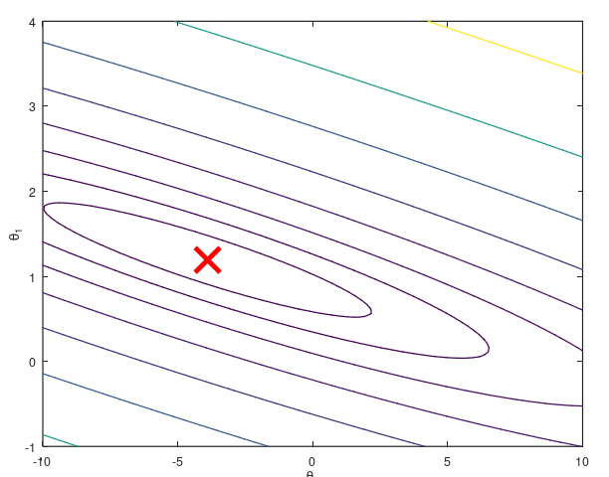

* **Excellent convergence, very low cost, but diminishing returns after a point.**

**Iteration 100**

**Partial convergence, higher cost, poor predictions (underfitting)**

**Iteration 1500**

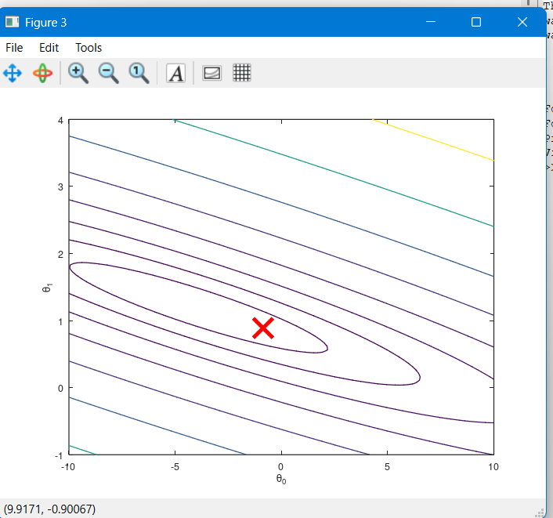

* **Good convergence, reasonably low cost, accurate predictions.**

**Linear Regression on Jupyter notebook**

**Input attribute from “Years of Experience”**

**Input attribute from “Age”**

**Years of Experience R squared Value=0.6528**

**Years of Age R squared Value= 0.5271**

**So in this R squared value is high on Years of Experience R squared input attribute and best attribute is Years of Experience**